بسم الله الرحمن الرحیم
فاطمه اثباتی
گزارش چهارم – مهندسی داده
دی ماه ۱۴۰۳

پیکربندی trino برای اتصال به hive
sudo mkdir /etc/trino/catalog

sudo nano /etc/trino/catalog/hive.properties
connector.name=hive
hive.metastore.uri=thrift://<metastore-host>:<port>

nano /usr/local/hive/conf/hive-site.xml
<property>
<name>hive.metastore.uris</name>
<value>thrift://<metastore-host>:<port></value>
</property>

sudo chown -R trino:trino /etc/trino/catalog
sudo chmod -R 755 /etc/trino/catalog

wget --no-check-certificate https://search.maven.org/remotecontent?filepath=io/trino/trino-cli/436/trino-cli-436-executable.jar -O trino-cli-436-executable.jar

sudo mv trino-cli-436-executable.jar /usr/local/bin/trino
sudo chmod +x /usr/local/bin/trino

trino –version
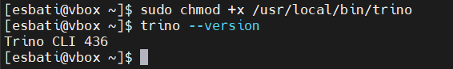
trino --server localhost:8080 --catalog hive --schema default
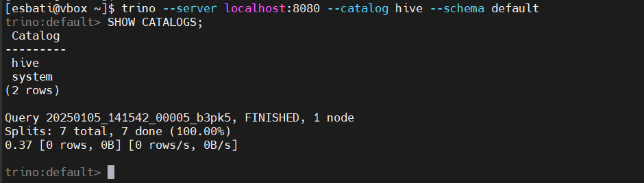

چالش:
مشکل زدن query
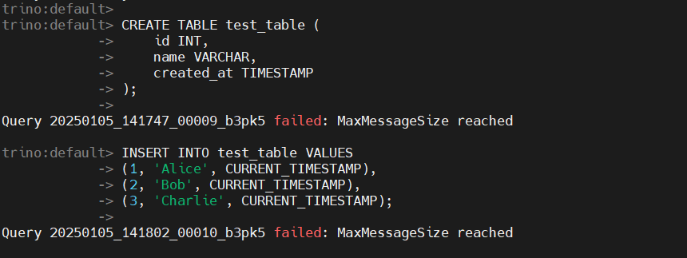
sudo nano /etc/trino/config.properties
# Maximum memory for queries
query.max-memory=4GB
query.max-memory-per-node=1GB
sudo service trino restart

sudo nano /etc/trino/catalog/hive.properties
hive.metastore.thrift.client.max-message-size=104857600
sudo service trino restart

cat /var/log/trino/server.log
none of them can not solve the problem so I search that to find out the answer in github
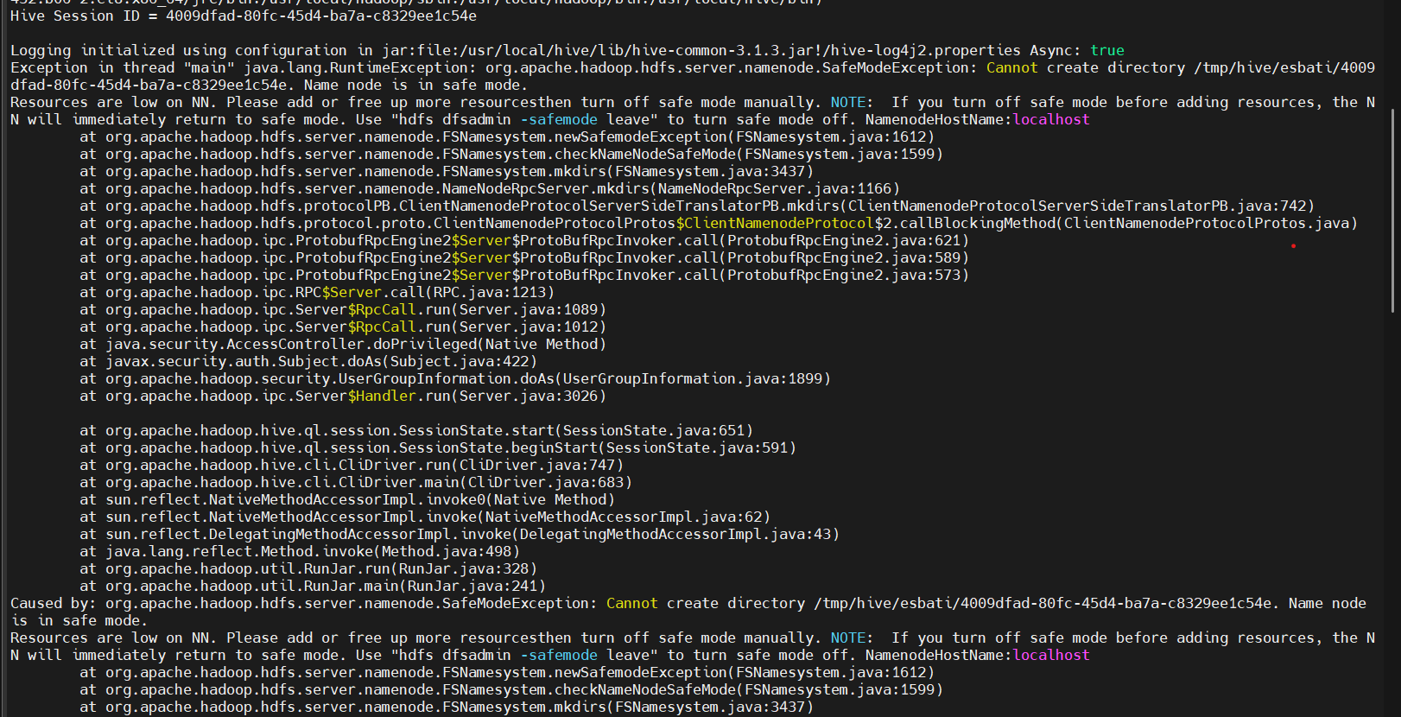
sudo nano /etc/hive/conf/hive-site.xml
<property>
<name>hive.metastore.thrift.max.message.size</name>
<value>104857600</value> <!-- 100 MB -->
</property>
<property>
<name>hive.server2.thrift.max.message.size</name>
<value>104857600</value> <!-- 100 MB -->
</property>

pkill -f hive
hive --service hiveserver2 &

Exit Safe Mode
hdfs dfsadmin -safemode leave
hdfs dfsadmin -safemode get
Run the following command to take the NameNode out of safe mode
But nothing change so I think the problem is because of my system lack of storage
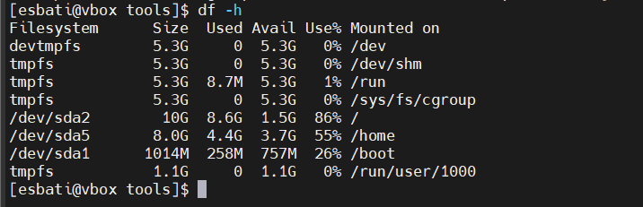
چالش ssh و دیدن صفحه وب در سیستم میزبان:
Guest
sudo systemctl stop firewalld
sudo systemctl disable firewalld
host
stop firwall from setting for windows

And I also did this when ssh to guest machin via cmd
Activate the web console with: systemctl enable --now cockpit.socket
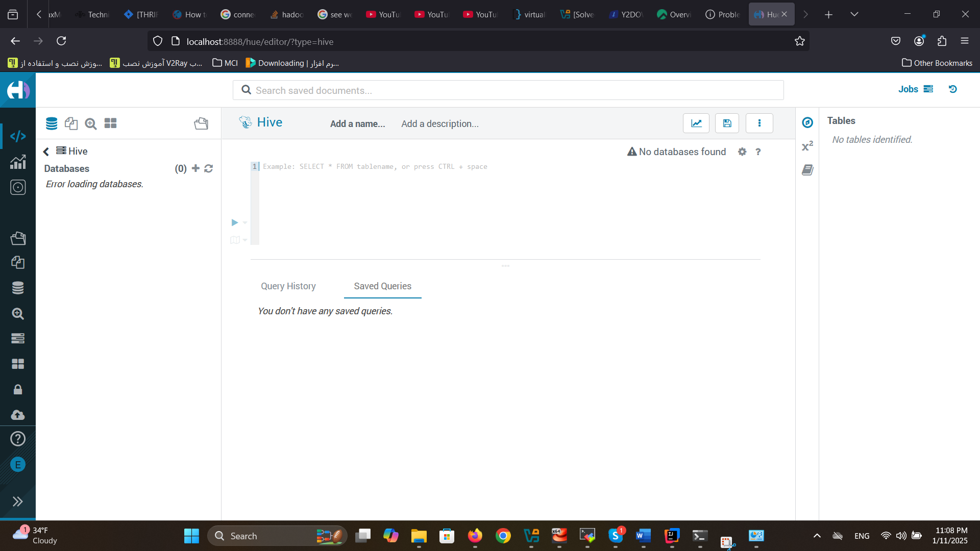
مشکل فایل دیتای tcp ds
https://github.com/kcheeeung/hive-benchmark

